Diserahkan: Diterima : Atas Talian:

(Font: Times New Roman, Uppercase, bold, 12, paragraph 1.15)
CRITERIA CONTENT OF ANIMATED SERIES UPIN AND IPIN FROM THE VIEW OF PRODUCTION LES’ COPAQUE COMPANY

(Font: Times New Roman, Uppercase, bold, 12, paragraph 1.15, Tajuk Bahasa Melayu)
KANDUNGAN KRITERIA SIRI ANIMASI UPIN DAN IPIN DARI PANDANGAN SYARIKAT PENGELUARAN LES' COPAQUE
(Font: Times New Roman, Capitalize 12)
^{i*}Siti Aisyah Yap Abdullah, ^{ii} Norrodzoh Hj Siren, ^{iii}Nurul Husna Mansor

(Font: Times New Roman, Capitalize 12)
^{i-iii}Department of Da’wah and Human Development, Academy of Islamic Studies,
University of Malaya, 50603 Kuala Lumpur, Malaysia.

(Font: Times New Roman, Capitalize 12)
Corresponding Author: e-mail: *sitiaisyah.yap@gmail.com

DOI :
(Font-Rumi: Times New Roman, Uppercase,bold 12) ABSTRACT
(Font: Times New Roman,12, 1.15 paragraph) Local animated works face great challenges when faced with animated films from the west, especially from the aspect to sustain the processing and organising of the product and company. However, the development…
(font: Times New Roman,12, 5 keywords) Keywords: Animation Technology, Animation Publishing Strategies, Animation Publishing Criteria, Multicultural Society in Animation, Upin and Ipin Animation

(Jenis font-Rumi: Times New Roman, INTRODUCTION
Uppercase,12 bold, 1.5 paragraph )
The history of animated films officially through the Malayan Film Unit or now better known as Film Negara began to present Hikayat Sang Kancil in 1983 (Azahar Harun and Russlan Abd Rahim, 2010). Technological sophistication in the early 90s produced the first serial animated films patterned on local cultures such as Usop Sontorian, Kampung Boy, Sidek's Children and Village Ball in 2 Dimensional forms. The mastery ……
Les Copaque (https://lescopaque.com/) is a French spelling named after the company’s studio. It is adapted from the word Last Kopek which means last chance and refers to the effort put together with dreams and hopes. The studio, which has Multimedia Super Corridor (MSC) status, uses 3D Animation, Computer Generated Image (CGI), and Autodesk Maya (Autodesk Inc, 2009) technology and operates in Shah Alam, Selangor. It was established in December 2005 …..
(Jenis font-Rumi: Times New Roman, METHODOLOGY OF RESEARCH
Uppercase,12 bold, 1.5 paragraph)
The methodology of this study collects data through interviews with informants due to their expertise. Information obtained from informants is a source of primary data, which is original information. The question method…
Based on the results of the interview, all the information is divided more specifically through the Cultural Organizational Theory presented by Denison and Mishra (1995). The description of the theory is as follows:
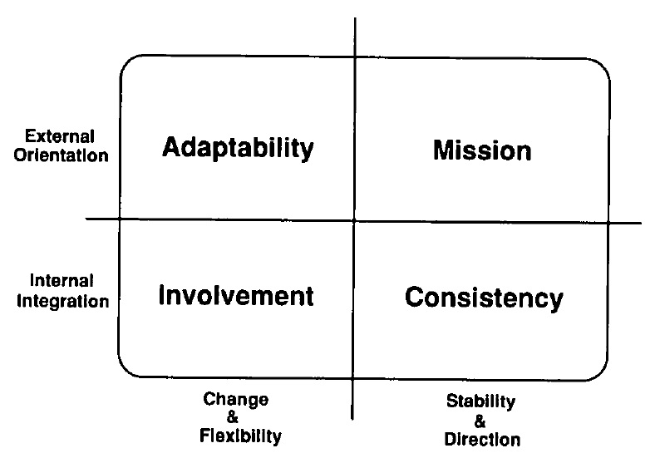

Figure 1: Theoretical Model of Culture Traits
All the dimensions found in the model have a division that is a measure of the theory. However, the scope of this study is limited …
Results of The Interview with Les’ Copaque Company
The criteria for publishing animated film content are general as it depends on specific circumstances. From the point of view of Les’ Copaque Company's management for each year, Mohd Zarin Abdul Karim …

(Jenis font-Rumi: Times New Roman, RESULTS AND FINDINGS
Uppercase,12 bold, 1.5 paragraph)

(Jenis font-Rumi: Times New Roman, DISCUSSION
Uppercase,12 bold, 1.5 paragraph)

(font-Rumi: Times New Roman, CONCLUSION
Uppercase,12 bold, 1.5 paragraph)
The practice of Les’ Copaque Company is seen to coincide with the Organizational Cultural Theory and the effectiveness as submitted by Denison and Mishra (1995) containing several internal and external criteria, the element of engagement, consistency, adaptation, and mission. When it comes…
(font-Rumi: Times New Roman, ACKNOWLEDGMENT
Uppercase,12 bold, 1.5 paragraph)

The authors express gratitude to Monash University Malaya for their support and facilities in conducting this research
(font-Rumi: Times New Roman, REFERENCE
Uppercase,12 bold)

Autodesk Inc, "Autodesk Maya brings Malaysia’s first 3D animation film to life on time, on budget," in Copyright page ©2009 Autodesk: Malaysia Customer Success Story: Les’ Copaque Production Sdn Bhd, http://images.autodesk.com/apac_sapac_main/files/les_copaquev9.pdf

